# Face detection using Haar Cascade

The system is built on off the shelf components and Intel’s algorithm to detect presence of face. **This DIY project is for informational purposes only. The author is not a professional and cannot be held responsible for any injuries or damages that may occur while following these instructions.**

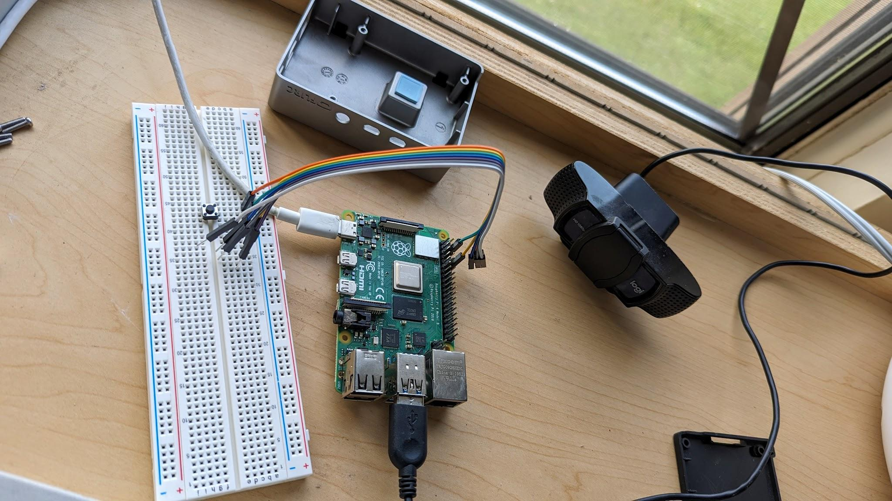  
Fig 1 : Hardware setup.

## List of Hardware:

* Raspberry Pi 4 model B
* Raspberry Pi case for heat dissipation
* Webcam
* Push button
* Soldering iron
* Breadboard

## Summary:

The code for the project can be found at <https://github.com/rez1ur>. This document was still a work in progress at the time of writing.

Main.py file opens a streaming service from attached webcam and capture the image when push button is pressed.   
  
It then sends a sms/email if a face/faces is detected.